**A MINI PROJECT REPORT ON**

**GST CALCULATOR**

**Submitted By**

**Bhargav Ram (160116737036)**

**Spandana                (160116737026)**

Under the guidance of

**Mrs . B. Veera Jyothi**

**Asst. Professor,**

**Dept. of IT, CBIT**



**DEPARTMENT OF INFORMATION TECHNOLOGY**

**CHAITANYA BHARATHI   INSTITUTE OF TECHNOLOGY**

**(Affiliated to Osmania University; Accreditated by NBA (AICTE), ISO Certified 9001:2000)**

**Website:** [**www.cbit.ac.in**](http://www.cbit.ac.in)

**HYDERABAD – 500 075**

**2017**

**CHAITANYA BHARATHI   INSTITUTE OF TECHNOLOGY**

DEPARTMENT OF INFORMATION TECHNOLOGY

**(Affiliated to Osmania University)**

**GANDIPET, HYDERABAD – 500 075**



**CERTIFICATE**

This is to certify that the project work titled “**GST Calculator**” submitted to **CHAITANYA BHARATHI INSTITUTE OF TECHNOLOGY,** in partial fulfilment of the requirements for the award of the completion of 3rd semester(CBCS) of B.E. in Information Technology, during the academic year 2017, is a record of original work done by **Bhargav Ram(160116737036)**and **Spandana(160116737026)** during the period of study in Dept. of IT, CBIT, HYDERABAD, under our supervision and guidance.

**PROJECT GUIDE  HEAD OF THE DEPARTMENT**

**Ms.B. Veera Jyothi   Dr . Suresh Pabboju**

Asst. Professor,       Head of the department

Dept. of IT, CBIT.       Information Technology

       CBIT, HYDERABAD

**DECLARATION**

This is to certify that the work reported in the present report titled “**GST Calculator**” is a record of work done by us in the Department of Information Technology, Chaitanya Bharathi Institute of Technology, Hyderabad.

No part of the report is copied from books / journals / internet and wherever the portion is taken, the same has been duly referred. The reported results are based on the project work done entirely by us and not copied from any other source.

Bhargav Ram(160116737036)

Spandana (160116737026)

**ACKNOWLEDGEMENT**

It is our privilege to acknowledge with deep sense of gratitude and devotion for keen personal interest and invaluable guidance rendered by our Project Guide   **Ms. B.Veera Jyothi**, Assistant Professor, Department of Information, Chaitanya Bharathi Institute of Technology.

We take the opportunity to express our thanks to**Dr. Suresh Pabboju,**Professor  & Head of IT Department, CBIT for his valuable suggestions and moral support.

Our respects and regards to **Dr.K Radhika**, Professor, Department of Information Technology, Chaitanya Bharathi Institute of Technology, for his invaluable suggestions that helped us in successful completion of the project.

We are grateful to our Principal **Dr.Ravinder Reddy** Chaitanya Bharathi Institute of Technology, for his cooperation and encouragement.

Finally, we also thank all the staff members, faculty of Dept. of IT, CBIT, our friends, and all our family members who with their valuable suggestions and support, directly or indirectly helped us in completing this project work.

**ABSTRACT**

Our webpage will clear all the confusions you have about GST, makes you understand better what it is, it’s impact and is provided with a calculator which gives the GST % ,rate and net price of the good or service availed.

**What is GST ?**

GST is a consumption based tax levied on sale, manufacture and consumption on goods & services at a national level. This is a single indirect tax for the whole nation and will be substitute for all indirect taxes levied by state and central government. Exports and direct tax like income tax, corporate tax and capital gain tax will not be affected . GST would apply to all goods and services barring a few to be specified. It is a single tax on the supply of goods and services, right from the manufacturer to the consumer.

Through GST, the government aims to create a single comprehensive tax. It will lead to the financial integration of India.

The GST Council, headed by Jaitley and of which all states Finance Ministers are members, has approved four main tax slabs -- 5 per cent, 12 per cent, 18 per cent and 28 per cent that aims to lower tax incidence on essential items and to keep the highest rate for luxury and demerits goods. The lowest rate of 5 per cent will be on items of mass consumption which are used particularly by common people. The second and third category of standard rates of 12 and 18 per cent will accommodate most of the goods and services. The fourth slab of 28 per cent is levied mainly on white goods such as refrigerators, washing machines etc.

**Languages Used :**

**Hypertext Markup Language (HTML)** -A standard markup language for creating web pages and web applications. It describes the structure of a web page semantically and originally included cues for the appearance of the document.

With Cascading Style Sheets (CSS) and JavaScript it forms a triad of cornerstone technologies for the World Wide Web.

**Cascading Style Sheets (CSS)** -A Style sheet language used for describing the presentation of a document written in a markup language. Most often used to set the visual style of web pages and user interfaces written in HTML and XHTML.

**JavaScript** - To add client-side behavior to HTML pages, also known as Dynamic HTML (DHTML)Scripts are embedded in or included from HTML pages and interact with the Document Object Model (DOM) of the page

**CONTENTSPAGE NO.**

1. **Introduction.** . . . . . . . . . . . . . . . . . . . . . . . . . . . . . . . . . . . . . . . . . . . . . . . . . . . . . 9

1.1. Overview. .  . . . . . . . . . . . . . . . . . . . . . . . . . . . . . . . . . . . . . . . . . . . . . . . . . 9

1.2. Existing System . . . . . . . . . . . . . . . . . . . . . . . . . . . . . . . . . . . . . . . . . . . . . .9

1.3. Aim of Project. . . . . . . . . . . . . . . . . . . . . . . . . . . . . . . . . . . . . . . . . . . . . . . .9

1.4. Organization of the Report. . . . . . . . . . . . . . . . . . . . . . . . . . . . . . . . . . . . . . 9

**2. Technologies . . . . . . . . . . . . . . .** . . . . . . . . . . . . . . . . . . . . . . . . . . .  . . . . . . . . . . .11

2.1. About HTML . . . . . . . . . . . . . . . . . . . . . . . . . . . . . . . . . . . . . . . . . . . . . . . 11

2.1.1. Introduction  . . . . . . . . . . . . . . . . . . . . . . . . . . . . . . . . . . . . . . . . .11

          2.1.2. HTML Basic tags . . .  . . . . . . . . . . . . . . . . . . . . . . . . . . . . . . . . . 11

                     2.1.3. HTML ATTRIBUTES . . . . . . . . . . . . . . . . . . . . . . . . . . . . . . . . .12

           2.1.4. HTML Images . . . . . . . . . . . . . . . . . . . . . . . . . . . . . . . . . . . . . . . 13

2.1.5. HTML Tables . . . . . . . . . . . . . . . . . . . . . . . . . . . . . . . . . . . . . . . .13

2.1.6. HTML Forms . . . . . . . . . . . . . . . . . . . . . . . . . . . . . . . . . . . . . . . 14

          2.2. About CSS . . . . . . . . . . . . . . . . . . . . . . . . . . . . . . . . . . . . . . . . . . . . . . . . . . 15

2.2.1. Introduction . . . . . . . . . . . . . . . . . . . . . . . . . . . . . . . . . . . . . . . . .15

           2.2.2. Syntax . . . . .. . . .. . . . . . . . . . . . . . . . . . . . . . . . . . . . . . . . . . . . . .15

2.2.3. Inclusion . . . . . . . . . . . . . . . . . . . . . . . . . . . . . . . . . . . . . . . . . . .16

2.2.4. CSS Padding . . . .. .. . . . . . . . . . . . . . . . . . . . . . . . . . . . . . . . . . . .17

2.3About Javascript. . . . . . . . . . . . . . . . . . . . . . . . . . . . . . . . . . . . . . . . . . . . . . . .18

2.3.1. Introduction. . . . . . . . . . . . . . . . . . . . . . . . . . . . . . . . . . . . . . . . . .18

2.3.2.Syntax. . . . . . . . . . . . . . . . . . . . . . . . . . . . . . . . . . . . . . . . . . . . . .18

**3. Software Requirement Specification** . . . . . . . . . . . . . . . . . . . . . . . . . . . . . . . . . . . 20

3.1. Introduction . . . . . . . . . . . . . . . . . . . . . . . . . . . . . . . . . . . . . . . . . . . .  . . . . 20

3.1.1 Purpose of the document . . . . . . . . . . . . . . . . . . . . . . . . . . . . . . . .20

3.1.2 Scope of the document . . . . . . . . . . . . . . . . . . . . . . . . . . . . . . . . .20

3.2. Users and their Characteristics . . . . . . . . . . . . . . . . . . . . . . . . . . . . . . . . . .20

3.3. Functional Requirements . . . . . . . . . . . . . . . . . . . . . . . . . . . . . . . . . . . . . .20

3.4. Software and Hardware Requirements. . . . . . . . . . . . . . . . . . . . . . . . . . . .20

**4. Implementation** . . . . . . .  . . . . . . . . . . . . . . . . . . . . . . . . . . . . . . . . . . . . . . . . . . . . 21

4.1. Introduction . . . . . . . . . . . . . . . . . . . . . . . . . . . . . . . . . . . . . . . . . . . . . . . . . .21

4.2.HTML. . . . . . . . . . . . . . . .. . . . . . . . . . . . . . . . . . . . . . . . . . . . . . . . . . . . . . 21

4.3.CSS . . . . . . . . . . . . . . . . . . . . . . . . . . . . . . . . . . . . . . . . . . . . . . . . . . . . . . . .21

4.4.JAVASCRIPT. . . . . . . . . . . . . . . . . . . . . . . . . . . . . . . . . . . . . . . . . . . . . . . . .21

4.5.Hosting the webpage. . . . . . . . . . . . . . . . . . . . . . . . . . . . . . . . . . . . . . . . . . . .21

**5. Testing and Results** . .   . . . . . . . . . . . . . . . . . . . . . . . . . . . . . . . . . . . . . . . . . . . . . .23

5.1. Introduction . . . . . . . . . . . . . . . . . . . . . . . . . . . . . . . . . . . . . . . . . . . . . . . . . . . . . . 23

5.2. Testing Objectives . . . . . . . . . . . . . . . . . . . . . . . . . . . . . . . . . . . . . . . . . . . . .23

5.3. Output Screens . . . . . . . . . . . . . . . . . . . . . . . . . . . . . . . . . . . . . . . . . . . . . . . 24

**6. Conclusion and Future Scope** . . . . . . . . . . . . . . . . . . . . . . . . . . . . . . . . . . . . . . . . .30

**7. Bibliography** . . . . . . . . . . . . . . . . . . . . . . . . . . . . . . . . . . . . . . . . . . . . . . . . . . . . . . 31

**LIST OF FIGURES**

**FIGURE NAME PAGE NO.**

Fig 5.1 Home Page. . . . . . . . . . . . . . . . . . . . . . . . . . . . . . . . . . . . . . . . . . . . . . . . . . . . .24

Fig 5.2 Food and Beverages. . . . . . . . . . . . . . . . . . . . . . . . . . . . . . . . . . . . . . . . . . . . . . 25

Fig 5.3 Apparels. . . . . . . . . . . . . . . . . . . . . . . . . . . . . . . . . . . . . . . . . . . . . . . . . . . . . . .26

Fig 5.4 Electronics. . . . . . . . . . . . . . . . . . . . . . . . . . . . . . . . . . . . . . . . . . . . . . . . . . . . . 27

Fig 5.5 Automobiles. . . . . . . . . . . . . . . . . . . . . . . . . . . . . . . . . . . . . . . . . . . . . . . . . . . .27

Fig 5.6 Services. . . . . . . . . . . . . . . . . . . . . . . . . . . . . . . . . . . . . . . . . . . . . . . . . . . . . . . 28

Fig 5.7 Information. . . . . . . . . . . . . . . . . . . . . . . . . . . . . . . . . . . . . . . . . . . . . . . . . . . .28

**LIST OF ABBREVIATIONS**

**Acronym Meaning**

HTML HyperTextMarkUp Language

CSS Cascading Style Sheets

SGST State Goods and Services Tax

CGST Central Goods and Services Tax

IGST Integrated Goods and Services Tax

**1 . INTRODUCTION**

* 1. **OVERVIEW**

GST Calculator is a webpage developed using HTML,CSS and Javascript.

It gives information regarding GST , the GST percent and price of goods and services

after GST is levied on it. The user has to enter price and click on calculate to get the

output.

HTML is used to develop the Web page and CSS is used to design the layout of the

webpageand the code is written in Javascript

* 1. **OLD SYSTEM**

Before GST, we had VAT and service tax which are taken separately as VAT is for goods and service is clearly for what it is mentioned. This taxation gives rise to a high tax rate as it has several indirect tax and that increases the tax rate along with every state having their own tax rate which increases the amount of tax rate as the goods are being transported from state to state. VAT was calculated on the value of sales of good or services which but with the tax rate that is already levied on the goods. But it changed to only paying tax on value addition and separately for the service. With GST coming into the picture the tax will be collected together without separate tax for goods and services.

* 1. **AIM OF THE PROJECT**

The aim of the project is to clear the confusion people have about GST and provide them with a GST calculator which gives percentage of tax levied on goods and services and final cost of the commodity.

* 1. **ORGANISATION OF REPORT**

**Chapter 1** deals with the Introduction of the project and gives the details about the

Project in an abstract view

**Chapter 2** deals with the information about html ,css,javascript and its utilization details

are discussed in brief

**Chapter 3** deals with the Software Requirements Specifications which is a specification

of the project software and hardware requirements

**Chapter 4** deals with the Implementation part which includes the tools and softwares that

are used.

**Chapter 5** deals with the Testing of the project and screenshots of the project

**Chapter 6** explains the Conclusion and further scope of the project.

**2.TECHNOLOGIES**

**2.1 ABOUT HTML**

**2.1.1 INTRODUCTION**

HTML stands for **H**yper **T**ext **M**arkup **L**anguage, which is the most widely usedlanguage on Web to develop web pages

* **Hypertext** refers to the way in which Web pages (HTML documents) are linked together. Thus the link available on a webpage are called Hypertext.
* As its name suggests, HTML is a **Markup Language** which means you use HTML to simply "mark up" a text document with tags that tell a Web browser how to structure it to display.

Originally, HTML was developed with the intent of defining the structure of documents like headings, paragraphs, lists, and so forth to facilitate the sharing of scientific information between researchers.

* + 1. **HTML Basic Tags**

1. **HEADING TAGS**

Any document starts with a heading. You can use different sizes for your headings. HTML also has six levels of headings, which use the elements **<h1>, <h2>, <h3>, <h4>, <h5>, and <h6>**. While displaying any heading, browser adds one line before and one line after that heading.

**2. PARAGRAPH TAGS**

The **<p>** tag offers a way to structure your text into different paragraphs. Each paragraph of text should go in between an opening <p> and a closing </p>tag .

3. **Line Break Tab**

Whenever you use the **<br />** element, anything following it starts from the next line. This tag is an example of an **empty** element, where you do not need opening and closing tags, as there is nothing to go in between them.

4.**Centering Content**

You can use **<center>** tag to put any content in the center of the page or any table cell.

**2.1.3 HTML ATTRIBUTES**

An attribute is used to define the characteristics of an HTML element and is placed inside the element's opening tag. All attributes are made up of two parts: a **name** and a **value**:

* The **name** is the property you want to set. For example, the paragraph <p> element in the example carries an attribute whose name is **align**, which you can use to indicate the alignment of paragraph on the page.
* The **value** is what you want the value of the property to be set and always put within quotations. The below example shows three possible values of align attribute: **left, center** and **right**.

Attribute names and attribute values are case-insensitive. However, the World Wide Web Consortium (W3C) recommends lowercase attributes/attribute values in their HTML 4 recommendation.

**CORE ATTRIBUTES**

1. **id Attribute**

The **id** attribute of an HTML tag can be used to uniquely identify any element within an HTML page. There are two primary reasons that you might want to use an id attribute on an element:

* If an element carries an id attribute as a unique identifier it is possible to identify just that element and its content.
* If you have two elements of the same name within a Web page (or style sheet), you can use the id attribute to distinguish between elements that have the same name.

1. **Title Attribute**

The **title** attribute gives a suggested title for the element. The behavior of this attribute will depend upon the element that carries it, although it is often displayed as a tooltip when cursor comes over the element or while the element is loading.

**2.1.4 HTML IMAGES**

Images are very important to beautify as well as to depict many complex concepts in simple way on your web page.

**INSERT IMAGES**

You can insert any image in your web page by using **<img>** tag. Following is the simple syntax to use this tag.

<imgsrc="Image URL" ... attributes-list/>

**SET IMAGE WIDTH /HEIGHT**

You can set image width and height based on your requirement using **width** and **height** attributes. You can specify width and height of the image in terms of either pixels or percentage of its actual size.

**2.1.5 HTML TABLES**

The HTML tables allow web authors to arrange data like text, images, links, other tables, etc. into rows and columns of cells.

The HTML tables are created using the **<table>** tag in which the **<tr>** tag is used to create table rows and **<td>** tag is used to create data cells.

**TABLE HEADING**

Table heading can be defined using **<th>** tag. This tag will be put to replace <td> tag, which is used to represent actual data cell. Normally you will put your top row as table heading , otherwise you can use <th> element in any row.

**TABLE CAPTION**

The **caption** tag will serve as a title or explanation for the table and it shows up at the top of the table.

**2.1.6. HTML FORMS**

## The <form> Element:The HTML <form> element defines a form that is used to collect user input.

## 1.The <input> Element

The **<input>** element is the most important form element and can be displayed in several ways, depending on the **type** attribute.

|  |  |
| --- | --- |
| **Type** | **Description** |
| <input type="text"> | Defines a one-line text input field |
| <input type="radio"> | Defines a radio button (for selecting one of many choices) |
| <input type="submit"> | Defines a submit button (for submitting the form) |

## 2.The Action Attribute

The **action** attribute defines the action to be performed when the form is submitted.Normally, the form data is sent to a web page on the server when the user clicks on the submit button. The form data is sent to a page on the server called "/action_page.php". This page contains a server-side script that handles the form data:

<form **action="/action_page.php**">

**3.The Method Attribute**

The **method** attribute specifies the HTTP method (**GET**or **POST**) to be used when submitting the form data:

<form action="/action_page.php" **method="POST"**>

* 1. **ABOUT CSS**

**2.2.1 INTRODUCTION**

**C**ascading **S**tyle **S**heets, fondly referred to as CSS, is a simple design language intended to simplify the process of making web pages presentable.

CSS handles the look and feel part of a web page. Using CSS, you can control the color of the text, the style of fonts, the spacing between paragraphs, how columns are sized and laid out, what background images or colors are used, layout designs, variations in display for different devices and screen sizes as well as a variety of other effects.

**2.2.2 SYNTAX**

A CSS comprises of style rules that are interpreted by the browser and then applied to the corresponding elements in your document. A style rule is made of three parts –

* **Selector** − A selector is an HTML tag at which a style will be applied. This could be any tag like <h1> or <table> etc.
* **Property** - A property is a type of attribute of HTML tag. Put simply, all the HTML attributes are converted into CSS properties. They could be color , border etc.
* **Value** - Values are assigned to properties. For example, color property can have value either *red* or *#F1F1F1* etc.

You can put CSS Style Rule Syntax as follows –

table{ border:1px solid #C00; }

**2.2.3 INCLUSION**

There are three ways to associate styles with your HTML document. Most commonly used methods are inline CSS and External CSS.

**INLINE CSS**

You can use *style* attribute of any HTML element to define style rules. These rules will be applied to that element only. Here is the generic syntax –

<elementstyle="...style rules....">

**EXTERNAL CSS**

The <link> element can be used to include an external stylesheet file in your HTML document.

An external style sheet is a separate text file with **.css** extension. You define all the Style rules within this text file and then you can include this file in any HTML document using <link> element.

Here is the generic syntax of including external CSS file –

<head>

  <link type = "text/css" href = "..." media = "..." />

</head>

**IMPORTED CSS**

@import is used to import an external stylesheet in a manner similar to the <link> element. Here is the generic syntax of @import rule.

<head>

  <@import "URL";

</head>

Here URL is the URL of the style sheet file having style rules. You can use another syntax as well –

<head>

  <@import url("URL");

</head>

**2.2.4 CSS PADDING**

The padding property allows you to specify how much space should appear between the content of an element and its border −

The value of this attribute should be either a length, a percentage, or the word *inherit*. If the value is inherit, it will have the same padding as its parent element. If a percentage is used, the percentage is of the containing box.

The following CSS properties can be used to control lists. You can also set different values for the padding on each side of the box using the following properties –

* The **padding-bottom** specifies the bottom padding of an element.
* The **padding-top** specifies the top padding of an element.
* The **padding-left** specifies the left padding of an element.
* The **padding-right** specifies the right padding of an element.
* The **padding** serves as shorthand for the preceding properties.
  1. **ABOUT JAVASCRIPT**

**2.3.1 INTRODUCTION**

JavaScript is used to define the behaviour of the webpage in response to the interaction with the user.It provides dynamic interactivity and provides services to the client side of the browser.

**2.3.2 SYNTAX**

**< ! - - JavaScript Functions - - >**

**< script language = “javascript” type = “ text / javascript ” >**

Function _fun_name_(/*Arguments*/){

/ / function definition

}

< /script >

JavaScript can be implemented using JavaScript statements that are placed within the **<script>... </script>** HTML tags in a web page.

You can place the **<script>** tags, containing your JavaScript, anywhere within your web page, but it is normally recommended that you should keep it within the **<head>** tags.

The <script> tag alerts the browser program to start interpreting all the text between these tags as a script.

The script tag takes two important attributes

**Language** − This attribute specifies what scripting language you are using. Typically, its value will be javascript. Although recent versions of HTML (and XHTML, its successor) have phased out the use of this attribute.

**Type** − This attribute is what is now recommended to indicate the scripting language in use and its value should be set to "text/javascript".

**3.SOFTWARE REQUIREMENT SPECIFICATION**

* 1. **INTRODUCTION**

The requirements specification is a technical specification of requirements for the software products. It is the first step in the requirements analysis process it lists the requirements of a particular software system including functional, performance and security requirements. The requirements also provide usage scenarios from a user, an operational and an administrative perspective. The purpose of software requirements specification is to provide a detailed overview of the software project, its parameters and goals. This describes the project target audience and its user interface, hardware and software requirements. It defines how the client, team and audience see the project and its functionality.

* + 1. **PURPOSE OF THE DOCUMENT**

This software requirement specification describes all the requirements elicited for “GST Calculator” and is intended to be used by the members examining the project and implementing and verifying the application. Unless otherwise noted all requirements are of high priority and are committed.

* 1. **USERS AND THEIR CHARACTERISTICS**

GST Calculator webpage is useful to the users to know more about GST and know the price of the commodity after tax is levied on it.

|  |  |
| --- | --- |
| Operating System | Windows |
| Programming Languages  Sever side Script | HTML , CSS  JavaScript |
| Processor | Intel® Core™ i3 |
| Ram | 1 GB or higher |
| Disk Space | 500 MB |

**4. IMPLEMENTATION**

**4.1 INTRODUCTION**

The success of the software product is determined only when it is successfully implemented according to the requirements. The analysis and the design of the proposed system provide a perfect platform to implement the idea using the specified technology in the desired environment. The implementation of our system is made user friendly.

Any software project is designed in modules and the project is said to be successfully implemented when each of the module is executed individually to obtain the expected result and also, when all the modules are integrated and run together without any errors.

**4.2 HTML**

HTML was used to build the basic structure and display the contents of the WebPages in the website. The basic structure of home page of the website and the articles were built using HTML. They have slight differences in their structures. It includes the CSS and Java Script files required for the website.

**4.3 CSS**

CSS was used to make the design of the website. The logo of the website and the layout of the header and footer was done using CSS. It was also used for the main layout design of the home page and the articles.

**4.4 JAVASCRIPT**

JavaScript is used to define the behaviour of the webpage in response to the interaction with the user.It provides dynamic interactivity and provides services to the client side of the browser

**4.5 HOSTING THE WEBSITE**

* The GST Calculator website is hosted using the functionality of GitHub.
* **GitHub** is a web-based Git or version control repository and Internet hosting service. It is mostly used for code.
* Small websites can be hosted from public repositories on GitHub. The URL format is <https://username.github.io./>

**5. TESTING AND RESULTS**

**5.1    INTRODUCTION**

Software testing is a critical element of software quality assurance and represents the ultimate review of specification, design and coding. In fact, testing is the one step in the software engineering process that could be viewed as destructive rather than constructive.

A strategy for software testing integrates software test case design methods into a well-planned series of steps that result in the successful construction of software. Testing is the set of activities that can be planned in advance and conducted systematically. The underlying motivation of program testing is to affirm software quality with methods that can economically and effectively apply to both strategic to both large and small-scale systems.

**5.2 TESTING OBJECTIVES**

The main objective of  performance testing is designed to test whether the website’s display is as expected and whether the website is functioning properly or not.

As the test results are gathered and evaluated they begin to give a qualitative indication of the reliability of the website. If proper output is not obtained, the overall quality of the Website is questioned. If, on the other hand, all the results which are not successful, are encountered, and are easily modifiable, then the following conclusion can be made: The tests are inadequate as the requirements mentioned are not compatible. The testing includes:

* Checking whether the information is displayed or not.
* Checking whether all the links between each webpage in the website works or is misdirected.
* Verifying if all the pictures are displayed and none of the files are corrupted.

**OUTPUT SCREENS**

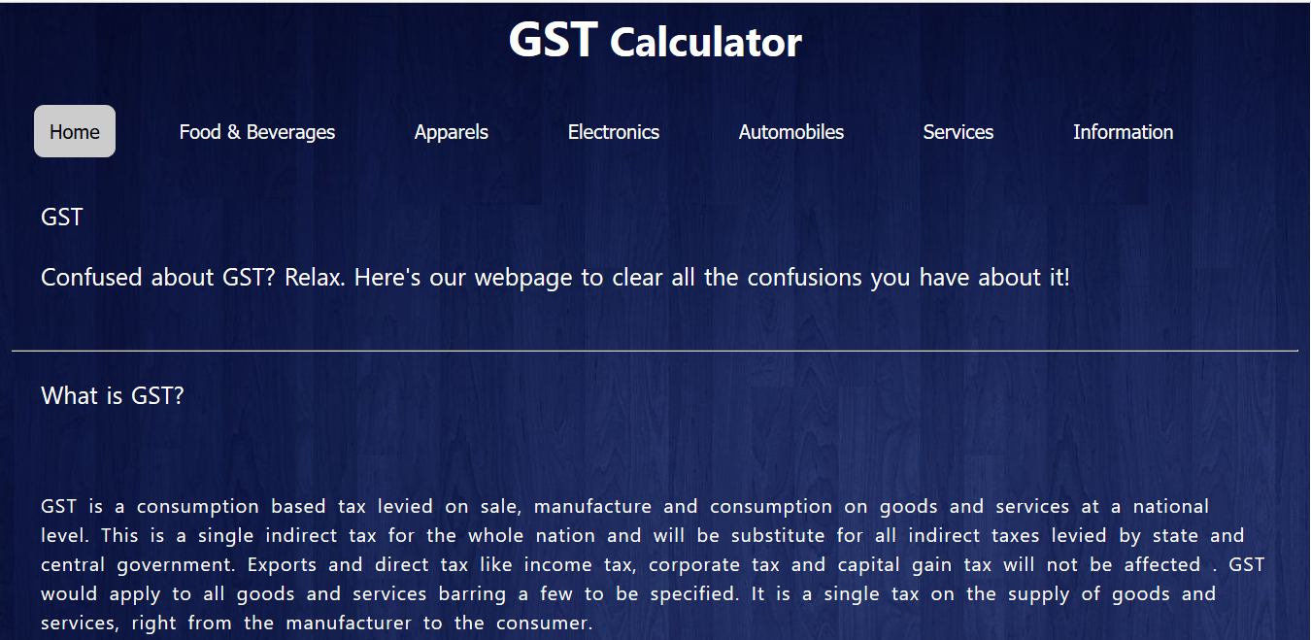

Fig 5.1.Home Page

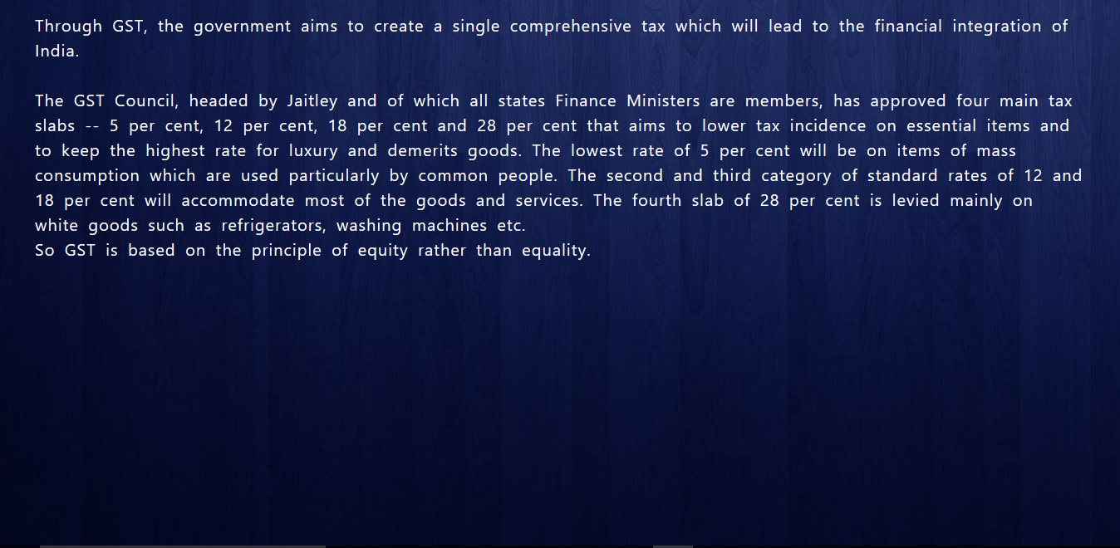

Fig 5.1.1. Home Page



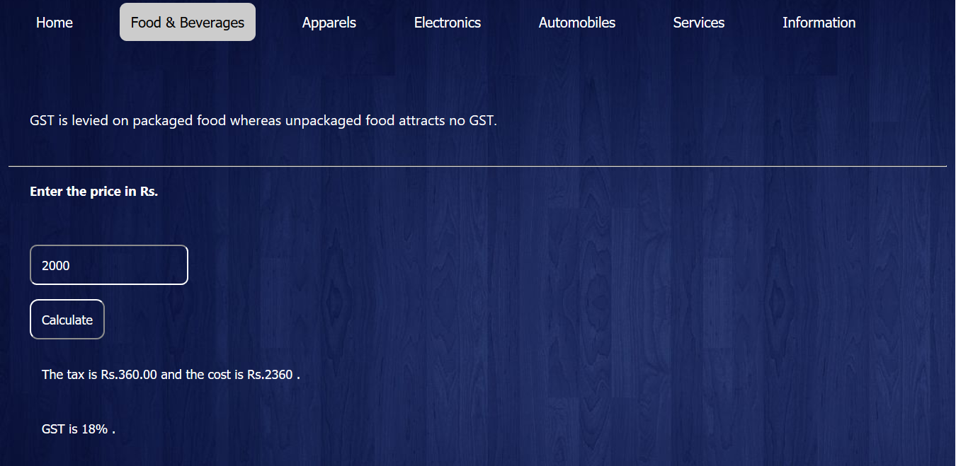Fig 5.1.2 Home Page

Fig.5.2 Food and Beverages

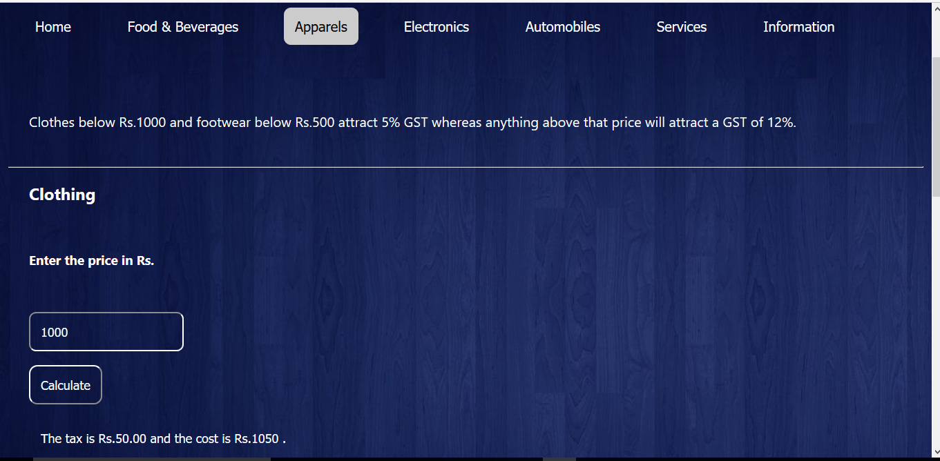

Fig 5.3 Apparels has two categories (a)Clothing



Fig 5.3.1 (b)Footwear

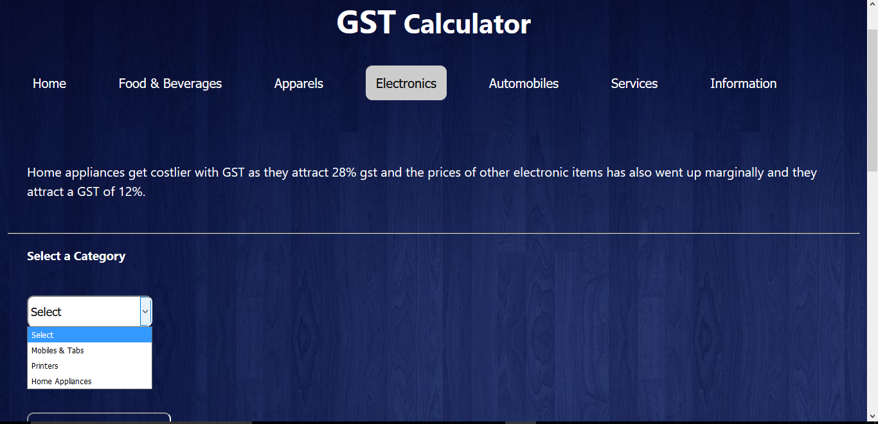

Fig 5.4 Electronics has three categories (a)Mobiles and Tabs (b)Printers (c)Home Appliances

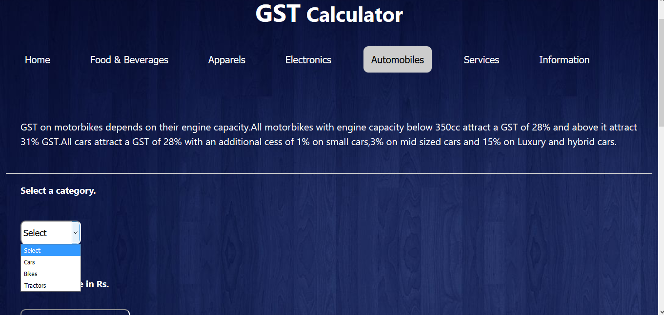

Fig 5.5 Automobiles has three categories (a)Cars (b)Bikes (c)Tractors

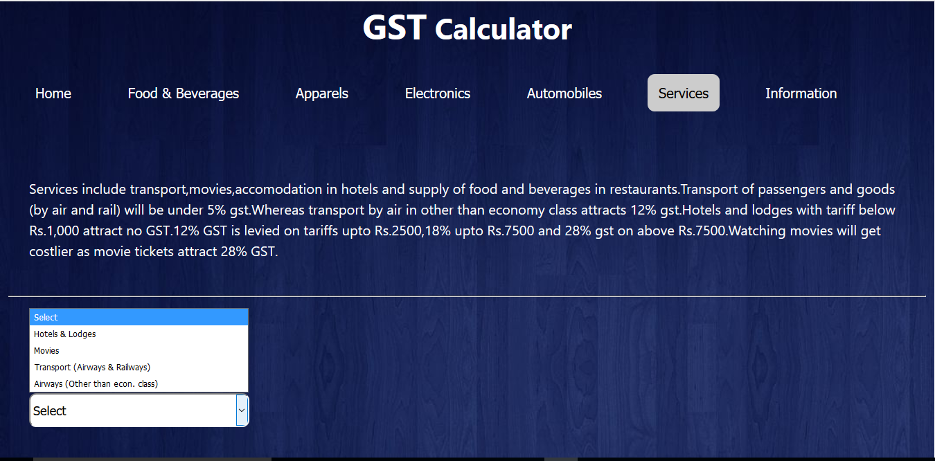

Fig 5.6 Services has three categories (a)Hotels & Lodges (b)Movies (c)Transport(airways and railways) (d)Airways(other than economy class)

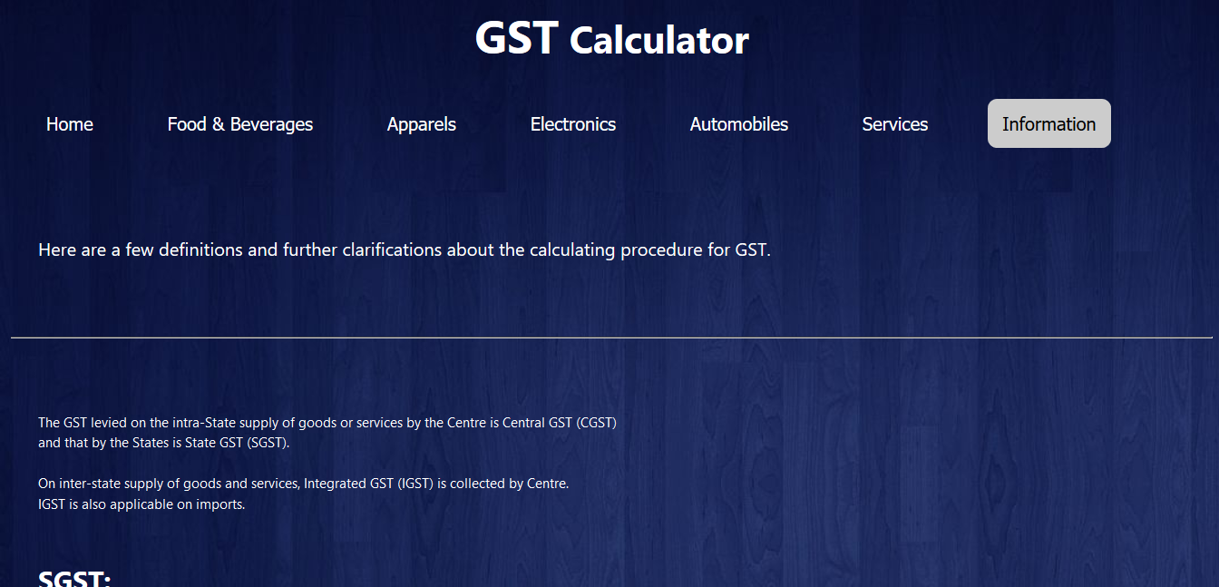

Fig 5.7 Information has a few definitions

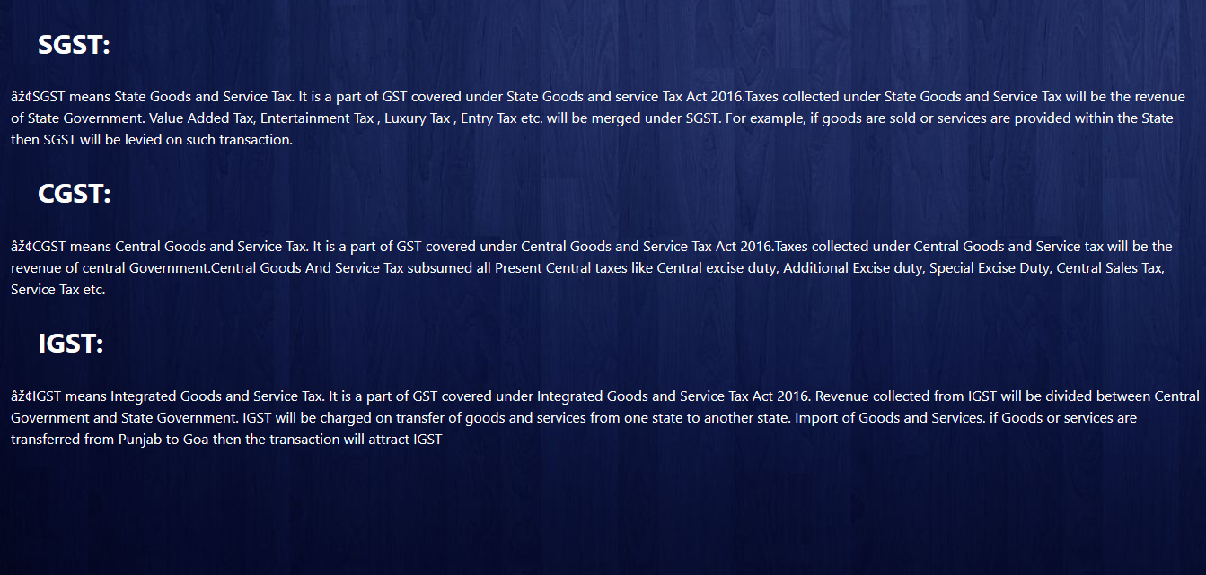

Fig 5.7.1 Defintions

**6.CONCLUSION AND FUTURE SCOPE**

Our webpage “GST” is designed in such a way that future modifications can be done easily.

It is one destination to give you a brief idea about the present taxation system that is after the implementation of GST.

Our webpage provides the following :

* It gives information about previous and current taxation system in brief
* It provides links to websites that give information about GST in detail
* It gives GST percentage
* It calculates cost of the good or service after GST is levied on it
* It calculates SGST and CGST
* It gives definitions of a few most important GST related terms

The next enhancement is, we want to create an android application. It’ll be easier for the users to know the cost of the commodity after GST is levied on it at a single click. We want to include features like calculating users monthly expenditure and savings. By saving the income details and list of commodities used in a month only once, the app should be able to calculate the users monthly expenditure and savings. It should give warnings when the balance is below a certain amount. By this app, we want to make it easier for the users to manage their monthly expenses .

**7.BIBLIOGRAPHY**

**BOOK REFERENCES –**

* HTML & CSS: Design and Build Web Sites

Book by Jon Duckett

* Professional JavaScript for Web Developers

by [Nicholas C. Zakas](https://www.amazon.in/s/ref=dp_byline_sr_book_1?ie=UTF8&field-author=Nicholas+C.+Zakas&search-alias=stripbooks)(Author)

**WEB REFERENCES**-

* <https://www.w3schools.com/>
* <https://www.tutorialspoint.com/html/>
* <https://www.tutorialspoint.com/css/>
* <https://www.tutorialspoint.com/javascript/>
* <https://www.economictimes.indiatimes.com/gst/>
* [www.indiatimes.com/](http://www.indiatimes.com/)
* [www.indiatvnews.com](http://www.indiatvnews.com/)
* <https://en.wikipedia.org/wiki/>